**Easy Difficulty**

**1. List All Products in the "Electronics" Category:**

* **Task:** Write an aggregation query to find all documents where the category is "Electronics".
* **Hint:** Use the $match stage.
* **Expected Output (structure, _id will vary):**

**Command:**db.products.aggregate([

{

$match: { category: "Electronics" }

}

]);  
  
gives records which has category as Electronics  
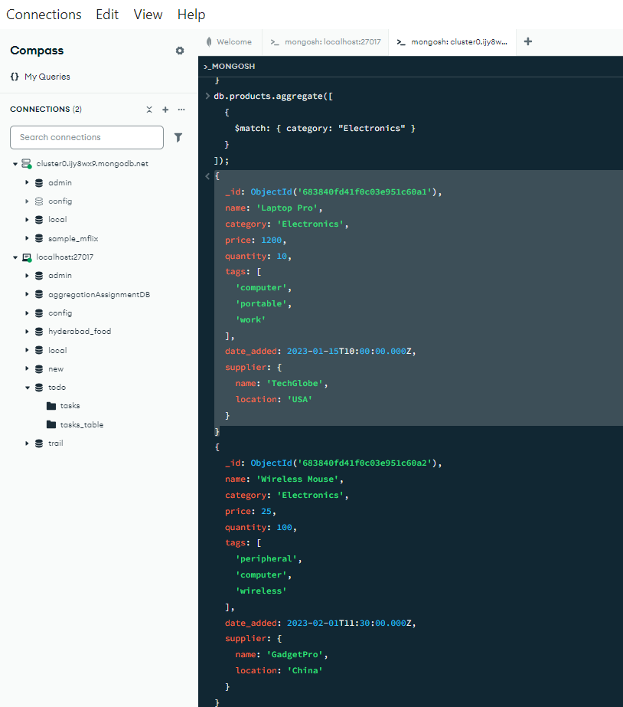

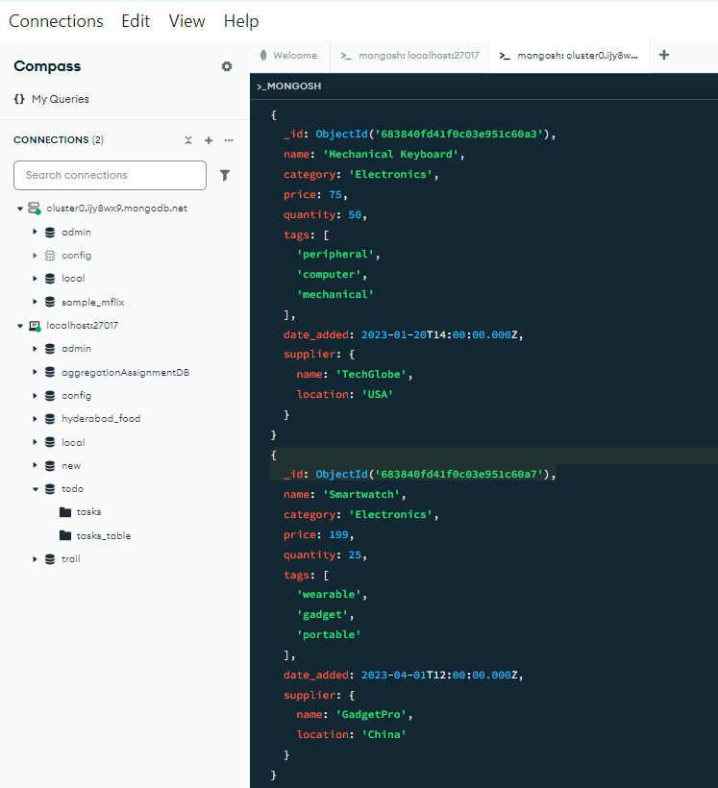  
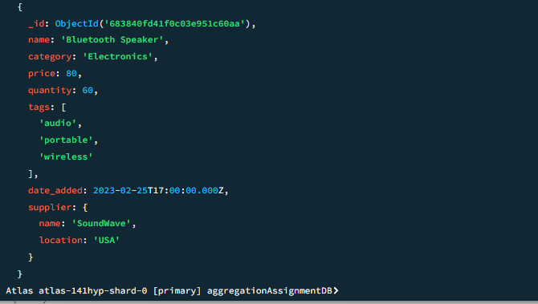  
**2. Count Products per Category:**

* **Task:** Write an aggregation query to count how many products belong to each category.
* **Hint:** Use the $group stage with the $sum accumulator.

**Command**db.products.aggregate([

{

$group: {

_id: "$category",   
 totalProducts: { $sum: 1 } }

}

]);

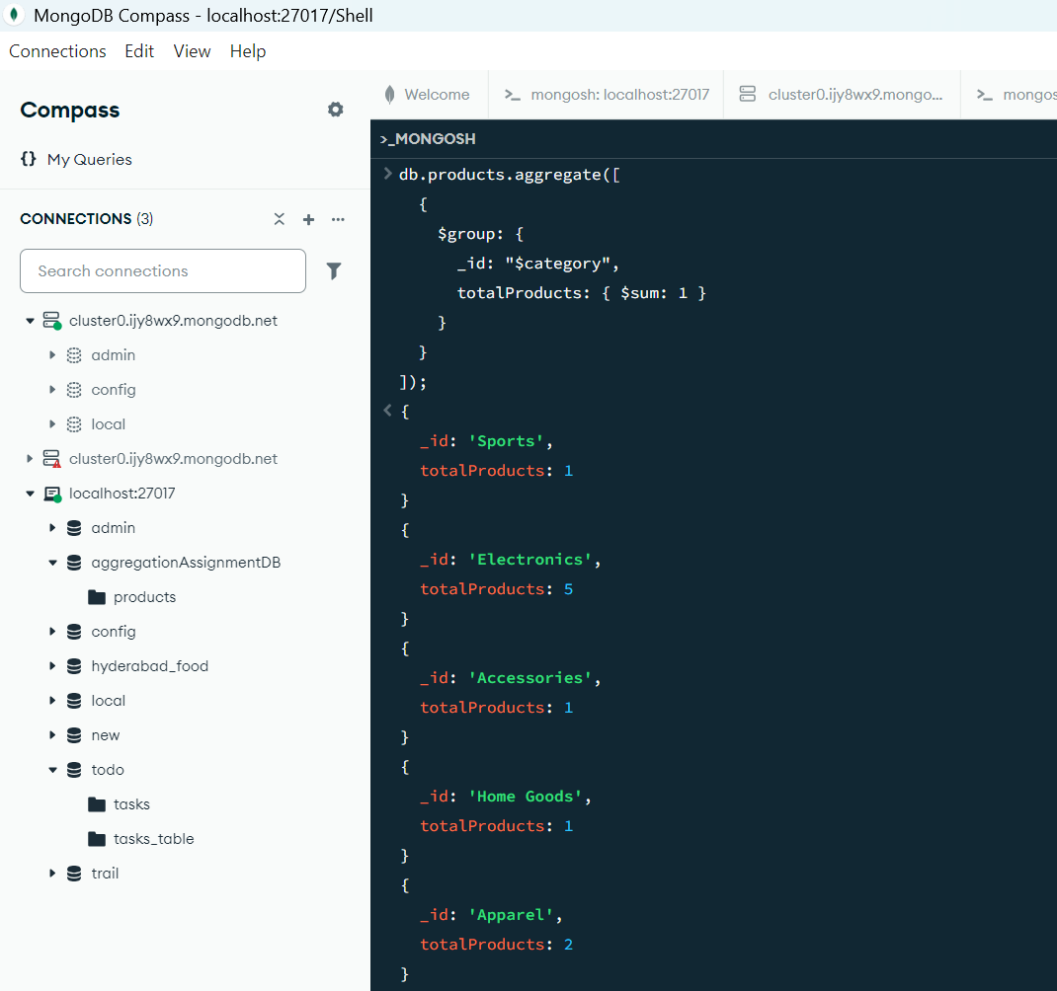  
we get no.of field for each categories  
  
 **3. Product Names and Prices, Sorted by Price (Descending):**

* **Task:** Write an aggregation query to display only the name and price of each product, sorted by price from highest to lowest. Do not include the _id field.
* **Hint:** Use $project and $sort.  
  **Command**db.products.aggregate([

{

$project: {

_id: 0,

name: 1,   
 price: 1

}

},

{

$sort: { price: -1 }

}  
]);  
